Gaian Asset Training Day Exercises

Author: David Vyvyan, IBM
Date: 28/05/2014

Table of Contents
I. General Overview 3
II. GUI – Logical Table path visualization 3
III. Framework extensions for data source wrapper VTIs 4
IV. Pluralized data sources 6
V. Configuration API – Batch updates 7
VI. Workload Management 8
VII. Policy extensions 10
VIII. Embeddability 12
IX. Distributed Processing 13
X. In-Development features – Web Services VTI 13

General Overview

This document should be used in conjunction with the “Gaian Asset Training Day.ppt” slides which give an overview of the features in these exercises below.

This document covers worked examples to help acquire a better understanding of some of the notable new features in the Gaian Asset V2.1 since the research version V1.5 was published on the IBM developerWorks website.

Each of the following exercises can be worked through independently.

GUI – Logical Table path visualization

This exercise should help to understand how logical tables can be divided across a network of nodes. In particular, it demonstrates how the Topology Tab in the Dashboard GUI can assist in identifying:
- The logical tables defined on the entry-point node – using a drop-down list
- Other nodes having data sources for the same logical tables – using a path visualisation

We will start 7 nodes on a same machine. The standard Gaian install comes with 3 sample configuration files for launching 3 nodes. We will copy these to accommodate for the 7 nodes.

- Open a DOS batch window and navigate to your Gaian install directory
cd <Gaian install path>

- Copy existing configuration files to create 4 new ones:
cp gaiandb_config2.properties gaiandb_config4.properties
cp gaiandb_config2.properties gaiandb_config6.properties
cp gaiandb_config3.properties gaiandb_config5.properties
cp gaiandb_config3.properties gaiandb_config7.properties

- Start the nodes, passing the number of nodes (7):
launchMultipleNodes.bat 7

- Start the Dashboard, then view the paths leading to logical table LT0:
dashboard.bat
→ Connect, then click ‘Network Topology’ tab, view network of 7 nodes then select target logical table ‘LT0’ – all nodes should have this defined with a data source.

- Remove a logical table from one of the nodes, and note the change in the paths:
queryDerby.bat -p 6419 "call removelt('lt0')"
→ Logical table paths should no longer pass through or reach the node assigned to port 6419.

Framework extensions for data source wrapper VTIs

This exercise should help understand how to add a custom data source wrapper (VTI) to Gaian, such as the AccumuloVTI or MongoDB VTIs.
We will use a basic VTI Java template to build a “Hello World” example.

For reference, below is Gaian’s high-level architecture diagram, as delivered for ITA.
VTIs are pictured in the stacks of green rectangles in the Yellow box.
The main thing to draw from this is that multiple instances of a VTI are used for every query (one per reference to a logical table accessing it), and these are all run in parallel.
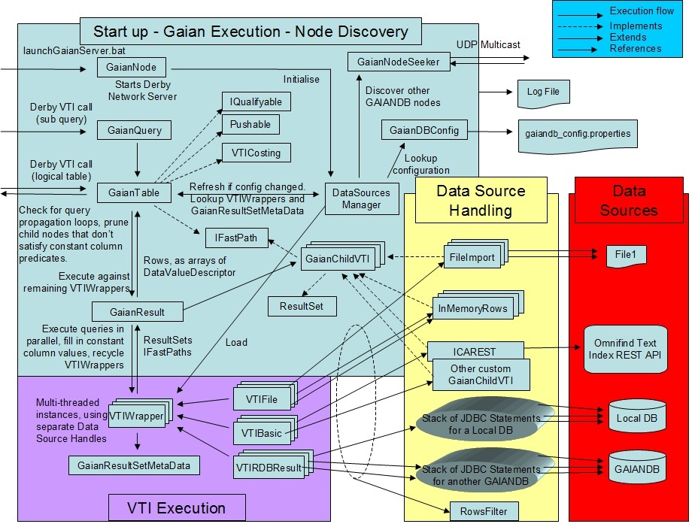
Figure 1 - Gaian Architecture

- Unzip IntegrationSamples.zip to your Gaian install folder (if not done already):
unzip IntegrationSamples.zip
cp IntegrationSamples <Gaian Install Folder>/

- Read/understand the Java template file for this exercise:
IntegrationSamples/vti/SampleHelloWorldVTI.java

→ Note that VTI methods are called according to the “query life-cycle”.
Logging in gaiandb.log will show all your VTI’s lines prefixed with your VTI class name – This gives a good indication of what method get called when.
→ Edit the various greeting messages (“Hello”, “World”, etc) to anything you like!

- Compile the Java code from Gaian’s install folder:
Windows/DOS:
javac -sourcepath IntegrationSamples -classpath "lib\GAIANDB.jar;lib\derby.jar" IntegrationSamples\vti\SampleHelloWorldVTI.java
Unix:
javac -sourcepath IntegrationSamples -classpath "lib/GAIANDB.jar:lib/derby.jar" IntegrationSamples/vti/SampleHelloWorldVTI.java

- Create a JAR library file with your class in it, and place the JAR in a location included in Gaian’s classpath so it can later find your vti class:
Windows/DOS:
jar -cf lib\MY_VTI.jar -C IntegrationSamples vti\SampleHelloWorldVTI.class
Unix:
jar -cf lib/MY_VTI.jar -C IntegrationSamples vti/SampleHelloWorldVTI.class

- Start or restart Gaian:
killGaianServers.bat
launchGaianServer.bat

- Create a new logical table and data source under it that accesses your VTI:
queryDerby.bat "CALL SETLT('MYLT', 'MESSAGE VARCHAR(32), TS TIMESTAMP', '')"
queryDerby.bat "CALL SETDSVTI('MYLT', '0', 'vti.SampleHelloWorldVTI', 'Blue', 'MAP_COLUMNS_BY_POSITION', '')"
- Query the new logical table and see your data:
queryDerby.bat "select * from MYLT"

→ Re-run this a few times and you should see different messages appear

- Asset extension 1 – VTI pooling:
Notice implementation of method ‘reinitialise()’ which is new in the Asset. This effectively re-cycles your VTI for another query. Gaian will pool and re-use VTIs whose reinitialise() method returns true.

Use API procedure ‘LISTDS’ to verify Gaian is pooling your VTI
queryDerby.bat "CALL LISTDS()"
→ Column DSWRAPPER shows the number of data source instances pooled.

- Asset extension 2 – Flexible VTI schema resolution:
By default, your VTI schema (i.e. set columns definition) is resolved from the logical table one.
However, your VTI schema may not always match the logical table one. For example the logical table may expose more or less columns or some columns may have different types or names.
Set a static custom VTI schema like this:
queryDerby.bat "CALL SETCONFIGPROPERTY('SampleHelloWorldVTI.schema', 'MSG VARCHAR(32)')"

→ This detaches your VTI table definition from the logical table one, which then gives you more freedom to assign column mappings

- Asset extension 3 – VTI columns mapping:
You may wish to map your VTI columns to columns in different positions in the logical table.
For example, if you insert a column ‘NAME’ at the start of the logical table definition:
queryDerby.bat "CALL SETCONFIGPROPERTY('MYLT_DEF', 'NAME VARCHAR(50), MESSAGE VARCHAR(32), TS TIMESTAMP')"

Then you will get the message appearing incorrectly in the ‘NAME’ column:
queryDerby.bat "select * from MYLT"
Therefore you will also need to shift the columns mapping for the VTI.
Disable option ‘MAP_COLUMNS_BY_POSITION’ and map column 2 from the logical table to VTI column “MSG” (defined in step 9):
queryDerby.bat "CALL SETDSVTI('MYLT', '0', 'vti.SampleHelloWorldVTI', 'Blue', '', 'C2=MSG')"

Run the query again to verify that the message now appears in the correct column:
queryDerby.bat "select * from MYLT"

→ Note that if the column names matched, then Gaian would resolve the mapping automatically by name

Pluralized data sources

This exercise should help understand the purpose and use of the ‘PLURALIZED’ option for Gaian logical table data sources.
Pluralization of a data source makes it possible for a data source to expose data for a dynamic set of endpoints. This effectively removes the need for an application to resolve data-endpoints, and simplifies the required configuration.
We will first show how to configure pluralisation for the built-in FileImport VTI.
We will then show how to extend a custom VTI to pluralize it.

- Modify the data source for sample logical table LT0 to federate multiple files:

Re-create the first data-source for logical table LT0 using option ‘PLURALIZED’
and the wildcard character ‘*’ to federate all files whose name starts with “datafile” and with the extension “.dat”:
queryDerby.bat "CALL SETDSFILE('LT0', '0', 'csvtestfiles/datafile*.dat', 'PLURALIZED', 'C1=COLUMN2,C2=COLUMN3,C3=COLUMN1')"

REGEX expressions are also supported. They are more complex but allow more control. For more detail refer to the asset’s Readme.html.

Now start Gaian (if not already running):
launchGaianServer.bat

Now query LT0 to see the effects:
queryDerby.bat "select * from LT0_P"

→ You should see records for all 3 files under folder csvtestfiles\
→ Provenance column GDB_LEAF shows you all the resolved files

- Pluralise a custom VTI:
Repeat steps 1-5 of exercise III. “Framework extensions for data source wrapper VTIs”, but with source code file: IntegrationSamples/vti/SamplePluralizedVTI.java

The SamplePluralizedVTI implements methods to tell Gaian what its endpoint IDs are, as well as any endpoint constants it may have for each one. For example with FileImport VTI the endpoint constants could be the file names. Any predicates specified against endpoint constant columns are resolved before the data source is invoked.
Configure the logical table and data source to access this VTI:
queryDerby.bat "CALL SETLT('MYLT', 'USRCPU INT, SYSCPU INT, DATA_SOURCE_IP VARCHAR(64), AGENT_INSTANCE INT', '')"
queryDerby.bat "CALL SETDSVTI('MYLT', '0', 'vti.SamplePluralizedVTI', 'CPU_MONITOR','PLURALIZED WITH ENDPOINT CONSTANTS C3 C4', '')"
queryDerby.bat "call setconfigproperty('SamplePluralizedVTI.CPU_MONITOR.schema','USRCPU INT, SYSCPU INT, DATA_SOURCE_IP VARCHAR(64), AGENT_INSTANCE INT')"

→ Try querying this VTI
queryDerby.sh "select * from MYLT_P"

→ This VTI exposes 2 endpoints, so Gaian creates 2 instances of your VTI for every reference to the logical table

Configuration API – Batch updates

This exercise shows how to apply a large number of configuration updates in an efficient manner to minimise I/O disk activity and start-up latency of an application requiring many logical tables and data sources to be created.

- Start or restart Gaian
killGaianServers.bat
launchGaianServer.bat

- Use API procedure ‘SETCONFIGPROPERTIES’ to load a set of configuration properties defining multiple logical tables:

queryDerby.sh "CALL SETCONFIGPROPERTIES ('SELECT * FROM (VALUES (''CUSTOMERS_DEF'', ''ID INT, NAME CHAR(50)''), (''SALES_DEF'', ''CUST_ID INT, ITEM_ID INT, TS TIMESTAMP''), (''STOCK_DEF'', ''ITEM_ID INT, NAME CHAR(50), PRICE DOUBLE'')) as T(pkey,pval)')"

→ This creates several logical tables in a single operation – you could add properties to also create data sources for these.
→ The configuration file is only updated once with all the new properties – this is the most efficient way of registering a lot of logical table structures.
→ Note that the string argument passed to ‘SETCONFIGPROPERTIES’ is limited in length to 32672 characters. If you reach that limit, a better solution is to write your properties to a local derby table and SELECT from that table instead of doing it all in one statement as in this example.

Workload Management

This exercise demonstrates how to monitor a query, and how to cancel one that may be running for too long or how to prevent this from happening by setting a timeout on the query in advance. It also demonstrates the use of other utility APIs for problem diagnosis: LISTTHREADS() and LISTWARNINGS()

- Start or restart Gaian:
killGaianServers.bat
launchGaianServer.bat

- Start a dashboard window:
dashboard.bat

- Run a large JOIN query from the command line:
This is a 4-way self-JOIN against the built-in logical table DERBY_TABLES that generates a large Cartesian product (274^4 records ~ 5.6 billion records)
queryDerby.bat "select count(*) from derby_tables a, derby_tables b, derby_tables c, derby_tables d"

- Query monitoring – in the dashboard QueryTab, click drop-down list and choose:
call listqueries(-1)
→ This shows the hanging query as well as the listqueries() query (which is implemented as a GaianQuery() under the covers):

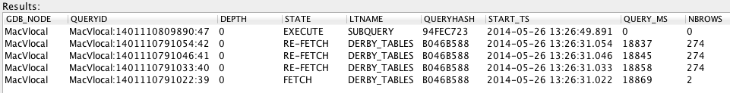
→ Notice how:
The JOIN has been split into 4 queries, one for each logical table instance.
The QUERYHASH is the same across the 4 instances so ties them together.
3 of the inner tables are being re-fetched continuously by the 4th.
The query completes when each instance reaches 274 rows

This information can help to diagnose possible issues with queries that may be long-running, hanging or stale/unclosed.

- Query cancellation
A long-running query can be aborted using a QueryID identified with LISTQUERIES above.
In this case, you need to cancel the branch of the query that is driving the others (this is the query in the ‘FETCH’ state above):
call cancelquery('MacVlocal:1401110791022:39')

→ If you cancel the wrong branch of the JOIN, its state will just change to ‘CACHED’, but the outer query will continue running.

→ Note that a ‘hanging’ query is different to ‘long-running’ ones as above in that it cannot generally be aborted in the same way because it is likely stuck waiting on a system i/o operation.

- Query timeout
A timeout (in milliseconds) can be specified in the comment field of a query:
queryDerby.bat "select count(*) from derby_tables a, derby_tables b, derby_tables c, derby_tables d -- GDB_TIMEOUT=10000"

→ This should automatically abort the query after roughly 10 seconds.

- Other problem diagnosis APIs: LISTTHREADS and LISTWARNINGS

An interesting monitoring API is:
call listthreads()
→ This shows all the Java running threads in the Gaian node.
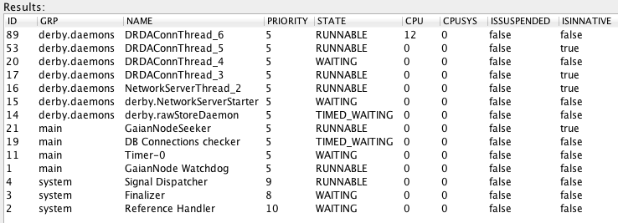

This information helps to verify the state of the core Gaian threads, the number of query threads, and whether any of the threads is consuming excessive CPU. This picture was taken while the large JOIN was running which explains the 12% CPU value.

Finally, any warnings that a Gaian node has raised can be retrieved with:
call listwarnings()
→ Since asset version 2.1.3, warnings are aggregated and retained throughout the life of the node. The API also shows the time of first occurrence and the repeat count:

Policy extensions

This exercise should help understand how to integrate a Java policy plugin into Gaian. It also provides some information on the various policy methods, in particular recent additions to the Asset.
We will use a sample Policy Java source file.

- Unzip IntegrationSamples.zip to your Gaian install folder (if not done already):
unzip IntegrationSamples.zip
cp IntegrationSamples <Gaian Install Folder>/

- Read/understand the Java template file for this exercise:
IntegrationSamples/policy/SamplePolicyForClusterPrivacy.java

→ Find the code that resolves the Cluster ID of the query’s entry-point node and then applies policy to obfuscate one of the columns’ cells when the Cluster ID doesn’t match a given value.

- Compile the Java code from Gaian’s install folder:
Windows/DOS:
javac -sourcepath IntegrationSamples -classpath "lib\GAIANDB.jar;lib\derby.jar" IntegrationSamples\policy\SamplePolicyForClusterPrivacy.java
Unix:
javac -sourcepath IntegrationSamples -classpath "lib/GAIANDB.jar:lib/derby.jar" IntegrationSamples/policy/SamplePolicyForClusterPrivacy.java

- Create a JAR library file with your class in it, and place the JAR in a location included in Gaian’s classpath so it can later find your policy class:
Windows/DOS:
jar -cf lib\MY_POLICY.jar -C IntegrationSamples policy\SamplePolicyForClusterPrivacy.class
Unix:
jar -cf lib/MY_POLICY.jar -C IntegrationSamples policy/SamplePolicyForClusterPrivacy.class

- Start or restart Gaian:
killGaianServers.bat
launchGaianServer.bat

- Activate the policy plugin:
queryDerby.bat "call setconfigproperty('SQL_RESULT_FILTER', 'policy.SamplePolicyForClusterPrivacy')"

- Test your policy by running an SQL query (from dashboard.bat or queryDerby.bat):
queryDerby.bat "select * from LT0"

→ The policy code will obfuscate the 1st column of the table
→ Notice how each method call into policy code has been logged in the Gaian server window

- Modify the ACCESS_CLUSTERS value for your node:
queryDerby.sh "call setAccessClusters('COMPANY_CLUSTER_1')"

- Re-run the query to verify that your policy now reveals the hidden cells:
queryDerby.bat "select * from LT0"

→ The full table should appear for LT0

Embeddability

This exercise should help understand how to embed Gaian inside a host application’s JVM. This has several benefits:
- Minimises memory overhead
- Allows the application to communicate directly with Gaian rather than via network connections.
- Allows the application to restart Gaian if necessary without having to restart the JVM

We will use a basic Java template embedding application as an example.

- Unzip IntegrationSamples.zip to your Gaian install folder (if not done already):
unzip IntegrationSamples.zip
cp IntegrationSamples <Gaian Install Folder>/

- Read/understand the Java template file for this exercise:
IntegrationSamples/embedding/SampleApplicationEmbeddingGaian.java

- Compile the Java code from Gaian install’s folder:
Windows/DOS:
javac -sourcepath IntegrationSamples -classpath "lib\GAIANDB.jar" IntegrationSamples\embedding\SampleApplicationEmbeddingGaian.java
Unix:
javac -sourcepath IntegrationSamples -classpath "lib/GAIANDB.jar" IntegrationSamples/embedding/SampleApplicationEmbeddingGaian.java

- Run the application and follow the prompts:
Windows/DOS:
java -cp "IntegrationSamples;lib\GAIANDB.jar;lib\GAIANDB-tools.jar;lib\db2jcutdown.jar;lib\derby.jar;lib\derbyclient.jar;lib\derbynet.jar" embedding.SampleApplicationEmbeddingGaian
Unix:
java -cp "IntegrationSamples:lib/GAIANDB.jar:lib/GAIANDB-tools.jar:lib/db2jcutdown.jar:lib/derby.jar:lib/derbyclient.jar:lib/derbynet.jar" embedding.SampleApplicationEmbeddingGaian

→ This starts Gaian in the wrapping application then runs a query internally against it. It also prints the threads that are active in its context while the Gaian task is running and after it has been shut down.

Distributed Processing
A worked example for this topic – which shows how Gaian can be used to implement the Map/Reduce paradigm – is covered in a separate set of slides: “Gaian Asset Training Day - V2 MAP_reduce.ppt” with associated “BIGDATA_MR_STATEMENTS.sql”

